4th Grade School Supplies

Pencils (Please consider the whole year!)
Pack of Dry Erase Markers (black preferred)
Black Sharpie (skinny)
Pack of Glue Sticks (4)
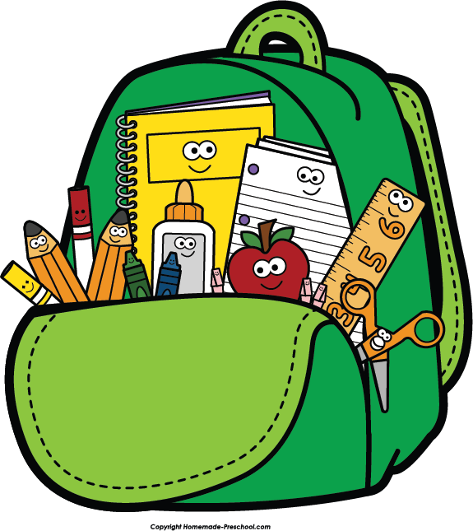
Pack of Highlighters (different colors)
Single Subject Spiral Notebooks (3)
Pocket Folders (1-red, 1-yellow, 1-blue)
3-ring Binder (1”)
5-tab Dividers
Pencil Box
Pencil Sharpener
Ruler (in & cm)
Scissors
Pack of Crayons
Pack of Markers
Pack of Color Pencils
Watercolor pallet
Pack of Lined Paper (wide ruled)
Ream of White copy paper
Kleenex (3 boxes for classroom use)
Ear buds

Classroom Wish List
(These items are for the whole class to share.)

Color Sticky Notes  Elmer’s Glue  Hand Sanitizer  Baby Wipes  Disinfectant Wipes  Pencil Top Erasers  Kleenex! | Color Pencils/Markers  Scrapbook Paper  Green, Purple, or Red Pens  Painters Tape (blue)  Packaging Tape (clear)  Address Labels (1”x25/8”)  Mailing Labels (2”x4”)

